2018 Spring Retirees’ Golf Outing Winning Teams / Players
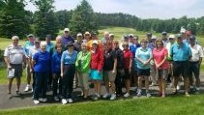

!st Place Winners: __Roger Roehl________________, __Paul Robert____________________
__Doug Wernicke______________, __Bob LaDuke_____________________
2nd Place Winners : _ Dan Kemp__________________, __Marion McGee_________________
_Bob Burns___________________, __Dean Kawa____________________
Ladies Closest To Pin #4: _Judy Burt__________; Ladies L. Drive #9:_Donna Roberts________
Ladies L. Drive #14:__Theresa Srebinski________________
Men’s Closest to Pin #6: _Dean Kawa________; Men’s L. Drive #11: _Bob LaDuke___________
Men’s L. Drive #16: _Roger Roehl_________

